7. Selection Sort on Random, Reverse and Sorted Arrays

Aim

To implement the Selection Sort algorithm on random, reverse-sorted, and already sorted arrays and analyze its performance.

Algorithm

Start.

Initialize three arrays: random, reverse-sorted, and already sorted.

Find the minimum element in the unsorted portion of the array.

Swap the minimum element with the first element of the unsorted portion.

Repeat the process until the entire array is sorted.

Display the sorted arrays.

Calculate and display the number of comparisons and swaps.

Stop.

Procedure
- Create random, reverse-sorted, and sorted arrays.
- Apply Selection Sort to each array.
- Select the minimum element from the unsorted portion.
- Swap it with the first unsorted element.
- Continue until all elements are in ascending order.
- Count the comparisons and swaps for performance analysis.
- Display the sorted arrays and their performance results.

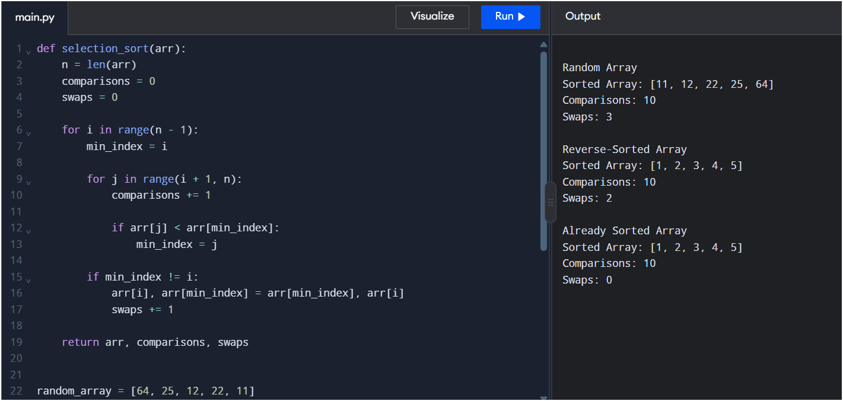

Result
Thus, Selection Sort was successfully implemented and tested on random, reverse-sorted, and already sorted arrays. The algorithm sorted all three arrays in ascending order with a time complexity of O(n²).

